“Sign Language Translator”
A Project Report Submitted in the partial fulfillment of the requirements for the award of the degree of

BACHELOR OF TECHNOLOGY
In
DEPARTMENT OF COMPUTER SCIENCE AND INFORMATION TECHNOLOGY
By

ALLAMSETTI LAHARI 2520090004
DEVAJI RASHMIKA 2520090152

Under the Esteemed Guidance of
Dr. Khaja Shareef
Assistant Professor

Department of Computer Science and Information Technology




K L (Deemed to be) University

DEPARTMENT OF COMPUTER SCIENCE AND INFORMATION TECHNOLOGY

Declaration

The Project Report entitled “Sign Language Translator” is a record of bonafide work of ALLAMSETTI LAHARI – 2520090004 , DEVAJI RASHMIKA - 250090152 submitted in partial fulfillment of the requirements of the course DATABASE SYSTEMS ENGINEERING AND DISTRIBUTED BACKEND DEVELOPMENT (25CS1302E), Section 12, Team 5, during 2026–2027, Trimester 4, at KLH University. The results embodied in this report have not been copied from any other student, department, or institution.

ALLAMSETTI LAHARI – 2520090004 DEVAJI RASHMIKA – 2520090152

K L (Deemed to be) University

DEPARTMENT OF COMPUTER SCIENCE AND INFORMATION TECHNOLOGY

CERTIFICATE

This is to certify that the project report entitled “Sign Language Translator” is a bonafide work done and submitted by ALLAMSETTI LAHARI – 2520090004 , DEVAJI RASHMIKA – 250090152 in partial fulfillment of the requirements of the course DATABASE SYSTEMS ENGINEERING AND DISTRIBUTED BACKEND DEVELOPMENT (25CS1302E), Section 12, Team 5, at KLH University
during 2026–2027, Trimester 4.

Signature of the Guide

Signature of the Course Coordinator Signature of the HOD

ACKNOWLEDGEMENT
The success in this project would not have been possible but for the timely help and guidance rendered by many people. Our wish to express my sincere thanks to all those who has assisted us in one way or the other for the completion of my project.

Our greatest appreciation to my Course Coordinator Dr.Khaja Shareef , and my guide Dr. Khaja Shareef, Department of Computer Science and Information Technology which cannot be expressed in words for his/her tremendous support, encouragement and guidance for this project.

We express our gratitude to Dr. Khaja Shareef, Head of the Department for Computer Science and Information Technology for providing us with adequate facilities, ways and means by which we are able to complete this project-based Lab.

We thank all the members of teaching and non-teaching staff members, and also who have assisted me directly or indirectly for successful completion of this project. Finally, I sincerely thank my parents, friends and classmates for their kind help and cooperation during my work.

ALLAMSETTI LAHARI – 2520090004 DEVAJI RASHMIKA – 2520090152

Abstract

The Communication is a basic human need, but for people who use sign language it is often a daily struggle. Sign language is a visual language that depends on hand shapes, facial expressions and body movement, and most people never learn it. As a result, signers face difficulties in schools, hospitals, offices and public places. Professional interpreters can help, but they are expensive, not always available, and too slow for natural, real-time conversations. The Sign Language Translator is a database-driven application designed to reduce this gap by recognising hand gestures as they happen and converting them into text and speech that anyone can understand.
The system works through a simple pipeline. A webcam captures the person's gestures in real time, and OpenCV preprocesses each video frame so it is easier to analyse. MediaPipe then detects the hand and extracts its landmark points, such as the fingers, joints and palm. These landmarks are passed to an AI/ML classification model, which compares them with the signs it has learned and identifies the best match. The recognised sign is displayed as readable text and, if the user wants, converted into speech so the other person can simply listen. The interface is built with HTML, CSS and JavaScript and is kept simple, so that anyone can use it without special training.
Behind the application, a MongoDB database keeps everything organised. It stores users, signs, their meanings, categories and translation records, and links related data through references so the same information is not repeated. Users can register, log in, search for any sign to see its meaning, and look back at their past translations. New signs and meanings can be added or updated at any time, which means the sign library keeps growing and the system improves with use. Overall, the project shows how a database, computer vision and machine learning can work together to build an affordable, real-time and accessible communication tool that helps people understand each other

Index
S.No. | Chapters | Topics | Page No.
 |  | Acknowledgement
 |  | Abstract
1 | Introduction | - Background of the Project  - Problem Statement  - Scope of the Project  - Objectives  - Importance of the Application  - Target Users / Audience | 5
2 | System Requirements | - Hardware Requirements  - Software Requirements  - Development Tools and Frameworks | 8
3 | Technology Stack | - Frontend  - Backend  - Database  - Version Control  - Authentication and Security Libraries | 9
4 | System Architecture | - High-Level Architecture Diagram  - Description of Each Layer  - Deployment Architecture | 10
5 | Design | - Database Design Principles  - ER Diagram / Database Schema  - Design Decisions and Assumptions | 12
6 | Implementation | - Module-wise Implementation  - Front-end Logic  - API Integration  - Authentication and Authorization | 13
7 | Features | - List of Main Features  - How Each Feature Works | 17
8 | Testing | - Postman API Testing  - Integration Testing  - Tools Used for Testing  - Test Cases and Results | 19
9 | Deployment | - Steps to Deploy  - Environment Configuration  - Hosting of Frontend and Backend | 20
10 | Challenges & Limitations | - Issues Faced During Development  - Solutions Applied  - Current Limitations or Known Bugs | 22

S.No. | Chapters | Topics | Page No.
11 | Future Enhancements | - Planned Features  - Possible Integrations or Optimizations | 23
12 | Conclusion | - Summary of the Project  - What Was Achieved  - Skills Learned | 24
13 | References | – Documentation, tools, and resources used | 25
14 | Appendices | - Sample Code Snippets  - Installation / Setup Instructions  - Default Login Credentials  - API Reference Summary  - Screenshots (to be added by the student) | 26

CHAPTER -1 INTRODUCTION

Background of the Project
Communication is an essential part of human interaction, but people who use sign language may face difficulties communicating with people who do not understand sign language. Sign language uses hand shapes, movements, positions, and facial expressions to convey information. Since most people are not familiar with sign language, communication barriers can occur in educational institutions, hospitals, workplaces, public services, and everyday situations. Although human interpreters can help, they may not always be available and may not provide an immediate solution for every interaction.
The Sign Language Translator is designed to reduce this communication gap by using computer vision and machine learning techniques to recognize hand gestures through a camera. The system continuously observes the user's hand movements, identifies whether one or two hands are being used, extracts important hand landmarks, and processes these features to recognize the corresponding gesture. The recognized gesture is then converted into text and can optionally be converted into speech, allowing the information to be understood by people who may not know sign language.

Problem Statement
The primary target users of the proposed Sign Language Translator are individuals who communicate using sign language and require an accessible means of communicating with people who do not understand sign language. The system is particularly intended to assist deaf and hard-of-hearing individuals by translating supported hand gestures into text and speech in real time. It can be used in everyday communication, educational environments, workplaces, public-service interactions, and other situations where direct communication may otherwise be difficult.
The secondary target users include individuals who do not have prior knowledge of sign language but need to communicate with sign-language users. This may include teachers, students, family members, colleagues, customer-service personnel, and other members of the general public. The system is designed to provide these users with an understandable representation of recognized gestures through text and speech, thereby supporting more convenient and efficient communication.

Scope of the Project
The Sign Language Translator is a real-time, camera-based system that uses computer vision and machine learning to recognize supported single-hand and two-hand gestures. It continuously tracks hand movements and converts recognized gestures into text and speech. The system provides a web-based interface for translation and history management, with recognition limited to the gestures supported by the implemented model.

Objectives
- Capture sign gestures in real time using a camera.
- Detect and process the hand in each video frame.
- Recognise individual signs using an AI/ML classification model.
- Convert the recognised gesture into readable text, and optionally into speech.
- Store users, signs, meanings, categories and translation history in an organised MongoDB
database.
- Keep the interface simple enough for anyone to use without training.

Importance of the Application
The Sign Language Translator is important because it provides a technology-based approach to reducing communication barriers between sign-language users and people who do not understand sign language. A real-time recognition system can provide immediate textual feedback without requiring another person to manually interpret every gesture. This can be useful in educational, professional, public-service, and everyday communication environments.
From a technical perspective, the project demonstrates the practical application of computer vision, hand tracking, machine learning, web development, and API-based software architecture. The project also demonstrates how camera input can be converted into structured landmark data and subsequently transformed into meaningful communication output. The modular design allows the recognition system to be improved by adding new gestures or replacing the recognition model without completely redesigning the application.

Target Users / Audience
The primary target users are sign-language users who need to communicate with people unfamiliar with sign language. The system also supports teachers, students, family members, and other individuals who interact with sign-language users by converting supported gestures into text and speech. It can be used in educational institutions, workplaces, and public-service environments as an assistive communication tool.

CHAPTER 2: SYSTEM REQUIREMENTS

Hardware Requirements
The Sign Language Translator requires a computer system capable of processing real-time camera input and running the Python-based application.
    - Processor: Intel Core i5 or equivalent
    - RAM: Minimum 8 GB
    - Storage: Minimum 10 GB free space
    - Camera: Built-in or external webcam, preferably 720p or higher
    - Display: 1366 × 768 resolution or higher
    - Internet: Required for installing dependencies and optional online services
    - Microphone/Speaker: Required for speech output, if applicable

Software Requirements
- Operating System: Windows 10/11 or Ubuntu Linux
- Programming Language: Python 3.x
- Frontend: HTML, CSS, JavaScript
- Backend: FastAPI
- Computer Vision: OpenCV
- Hand Tracking: MediaPipe
- Machine Learning: TensorFlow / required ML libraries
- Database: MongoDB
- Database Tool: MongoDB Compass
- API Server: Uvicorn
- Web Browser: Google Chrome / Microsoft Edge
- Code Editor: Visual Studio Code
- Version Control: Git and GitHub

Development Tools and Frameworks
The project is developed using Visual Studio Code as the primary code editor. Python and the required libraries are installed using pip, while a Python virtual environment is used to manage project dependencies. FastAPI and Uvicorn are used to develop and run the backend API.
MongoDB is used for storing application data, with MongoDB Compass providing a graphical interface for database management. Git and GitHub can be used for source-code management and team collaboration. A modern web browser such as Chrome or Edge is used to access and test the application interface.

CHAPTER 3: TECHNOLOGY STACK

Frontend
The frontend of the Sign Language Translator is developed using HTML, CSS, and JavaScript. HTML is used to structure the application interface, including login forms, camera sections, buttons, text-output areas, and translation history. CSS is used to design the layout, spacing, typography, buttons, and responsive elements. JavaScript provides interactive functionality such as handling user actions, communicating with the backend, accessing camera features, and updating translation results dynamically without requiring frequent page reloads.

Backend
Python is used as the primary backend programming language because it provides libraries and frameworks for computer vision, machine learning, API development, and database connectivity. FastAPI is used to develop the backend REST APIs that connect the frontend with the recognition and database components. It handles operations such as user authentication, gesture-processing requests, translation retrieval, and history management, while also providing automatic API documentation for testing and development.

Database
MongoDB is used as the database for storing application data such as user information, authentication details, recognized translations, and translation history, depending on the implemented modules. MongoDB Compass can be used to manage and inspect the stored data. The FastAPI layer acts as the communication bridge between the frontend, recognition system, and MongoDB, ensuring that requests are processed and appropriate responses are returned to the user interface.

Version Control
Git was used throughout development for version control, with the project structured as a single repository containing both the client and server codebases, hosted on GitHub.

Authentication and Security Libraries
The system includes an authentication module for managing user login and access to application features. Authentication functionality is implemented through the backend authentication module and integrated with the frontend interface.

CHAPTER 4: SYSTEM ARCHITECTURE

High-Level Architecture Diagram

The proposed Sign Language Translator follows a three-layer architecture consisting of the Presentation Layer, Application/Business Logic Layer, and Data Layer. The architecture integrates a webcam-based sign language recognition pipeline with a FastAPI backend and MongoDB database.

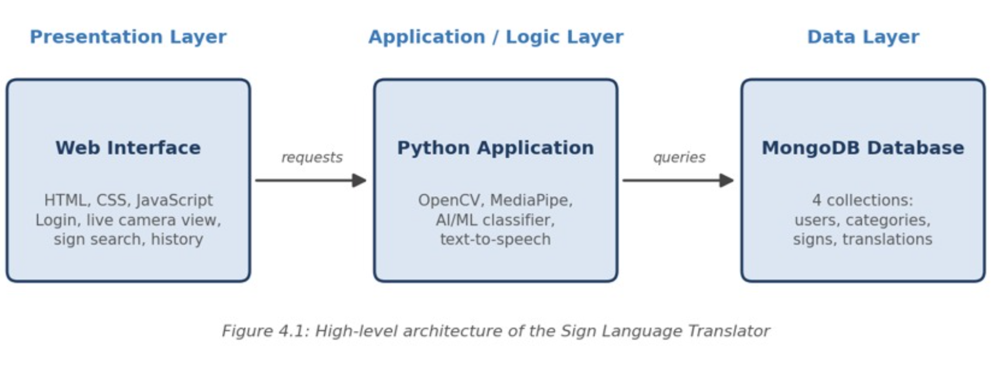

Description of Each Layer

The Presentation Layer is the web interface built with HTML, CSS and JavaScript. It shows the live camera view, the recognised text, the sign search page and the translation history. It does not store anything itself; every piece of data it shows comes from the application layer.

The Application Layer is the Python code that does the real work. It captures frames, cleans them with OpenCV, finds the hand and its landmarks with MediaPipe, and asks the AI/ML model to classify the sign. It also applies the business rules, such as checking that a user is logged in before saving a translation, and converts text to speech when the user asks for it.

The Data Layer is the MongoDB database. The application reads and writes it through a MongoDB driver for Python, and it holds the users, categories, signs and translation records.

Deployment Architecture

For development and demonstration, all the layers run on a single laptop or PC: the web interface in the browser, the Python application locally, and MongoDB as a local service. No containerisation or cloud deployment was set up for this submission, since the course scope did not call for it; Chapter 11 (Future Enhancements) outlines how the system could be extended to a hosted environment.

CHAPTER 5: DESIGN

Database Design Principles

MongoDB stores data as documents grouped into collections. Each document has a unique _id, and relationships between collections are expressed by storing the _id of the related document. This keeps every fact in exactly one place instead of copying it around. Unique indexes on fields such as a user's email and a sign's name prevent duplicates, and indexes on commonly searched fields keep lookups fast.

ER Diagram / Database Schema
The database consists of seven related tables, shown in Figure 5.1.
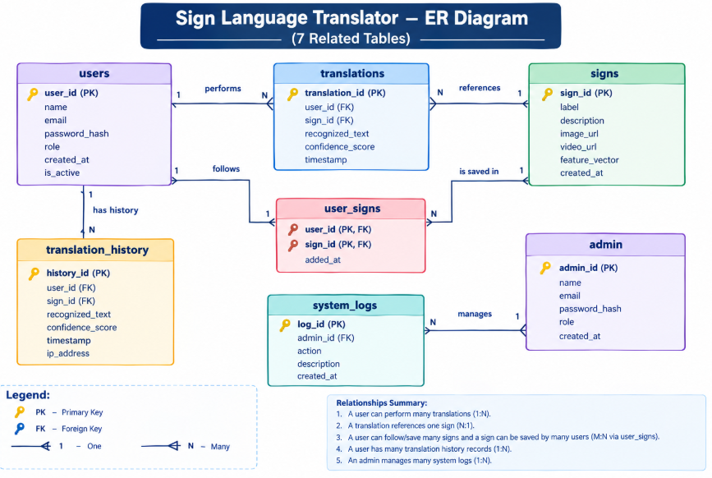
The database consists of seven related entities. USERS stores user accounts, roles, and passwords. SIGNS stores sign labels and feature data. TRANSLATIONS stores recognized signs and translated text. TRANSLATION_HISTORY stores previous translations. USER_SIGNS links users with saved signs. ADMIN stores administrator details, while SYSTEM_LOGS records administrative activities.
The main relationships are USERS–TRANSLATIONS (1:M), SIGNS–TRANSLATIONS (1:M), USERS–TRANSLATION_HISTORY (1:M), USERS–SIGNS (M:N through USER_SIGNS), and ADMIN–SYSTEM_LOGS (1:M).

Design Decisions and Assumptions

Two important design decisions were made for the Sign Language Translator:

Translations vs. Translation History: TRANSLATIONS stores the current translation result generated by the recognition system, while TRANSLATION_HISTORY maintains previous translation records for later reference. This avoids mixing active translation data with historical records.

Sign Recognition and Features: The SIGNS entity stores the sign label and its associated image/video and feature information. The extracted hand-landmark features from MediaPipe are used by the AI model for recognition, while the predicted sign and confidence score are stored with the translation result.

CHAPTER 6: IMPLEMENTATION

Module-wise Implementation

The system is organized into modules for Authentication, Sign Management, Sign Recognition, Translation, Translation History, and Administration. The Sign Recognition module captures webcam frames, preprocesses them using OpenCV, detects hand landmarks using MediaPipe, extracts relevant features, and passes them to the TensorFlow/Keras model for prediction. The Translation module converts the predicted sign into text and stores the result in MongoDB along with the confidence score and timestamp.

Front-end Logic

The frontend is implemented using HTML, CSS, and JavaScript. It provides the webcam interface, displays the live video stream, shows the recognized sign and translated text, and provides access to translation history and administrative functions. JavaScript handles user interactions, webcam access, API requests, and dynamically updates the recognition results without requiring continuous page reloads.

API Integration

All communication between the frontend and backend is handled through FastAPI REST APIs. The APIs process user requests, send recognition data to the appropriate processing modules, retrieve translation results, and perform MongoDB operations. Separate API endpoints are used for authentication, signs, translations, users, and translation history, keeping the frontend independent from the database implementation.

Authentication and Authorization

The system provides authentication for registered users and administrators. User passwords are stored securely using bcrypt hashing rather than plain text. Role-based authorization is used to distinguish normal users from administrators. Protected API endpoints verify the user's authentication before allowing access, while administrator functions are restricted to authorized admin accounts.

CHAPTER 7: FEATURES

List of Main Features

User-facing features:

Create an account and securely log in to the system.

Access the webcam for real-time sign language recognition.

Detect hand gestures using MediaPipe hand landmarks.

Preprocess captured frames using OpenCV.

Recognize signs using the trained AI/ML model.

Translate recognized signs into text continuously.

Convert translated text into speech using Text-to-Speech.

View translation confidence scores.

View previous translations through translation history.

Browse the available sign-language vocabulary.

Administrator-facing features:

Secure administrator login with role-based access.

Add, update, and delete sign-language entries.

Manage registered users.

View translation records and translation history.

Monitor recognized signs and confidence values.

View system activity and usage information.

Manage the sign-language dataset used by the recognition system.

How Each Feature Works
Real-time sign recognition: The webcam continuously captures video frames of the user's hand gestures. OpenCV preprocesses the frames, while MediaPipe detects the hand and extracts 21 hand landmarks. These landmarks are converted into features and passed to the trained TensorFlow/Keras model, which predicts the corresponding sign.
Text translation: Once a gesture is recognized, the predicted sign label is converted into readable text and displayed on the website. The recognized sign, translated text, confidence score, and timestamp can be stored in MongoDB.
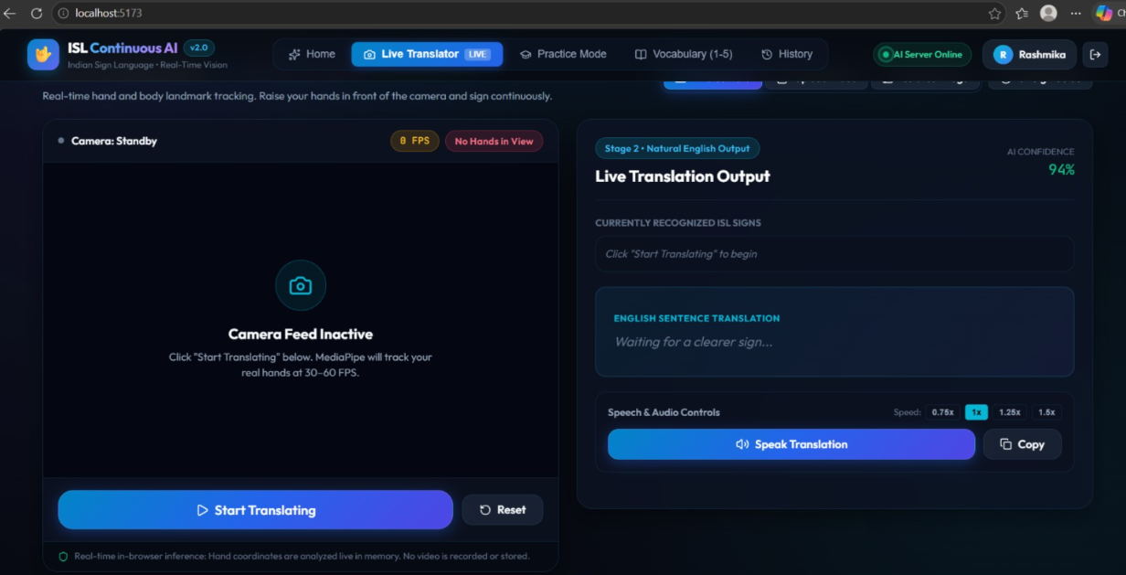
Speech output: The translated text is passed to the Text-to-Speech module, which converts the recognized text into audio, allowing the user to hear the translated result.
Translation history: Each completed translation can be stored with the associated user, recognized sign, translated text, confidence score, and timestamp. Users can access their previous translation records through the history section.
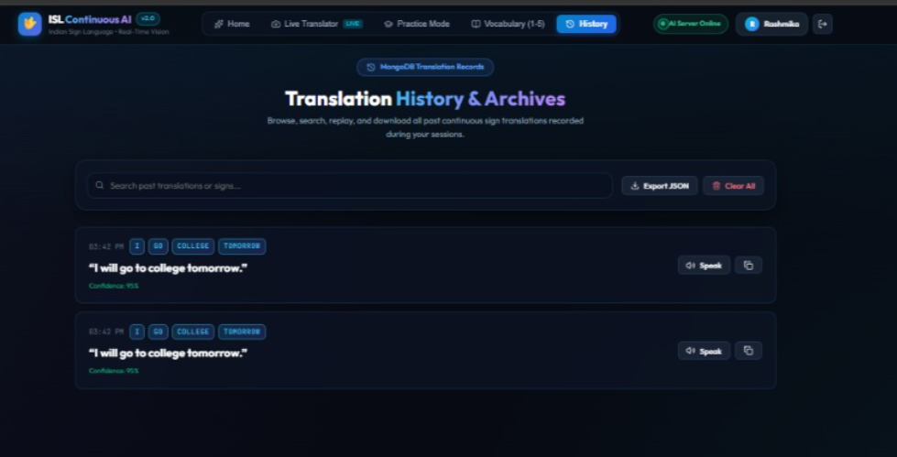
Sign management: Administrators can add, update, or remove sign entries and their associated feature information. This allows the vocabulary used by the recognition system to be maintained and expanded.
User and role management: The system separates normal users and administrators using role-based access. Users can perform translations, while authorized administrators can manage users, signs, and system records.
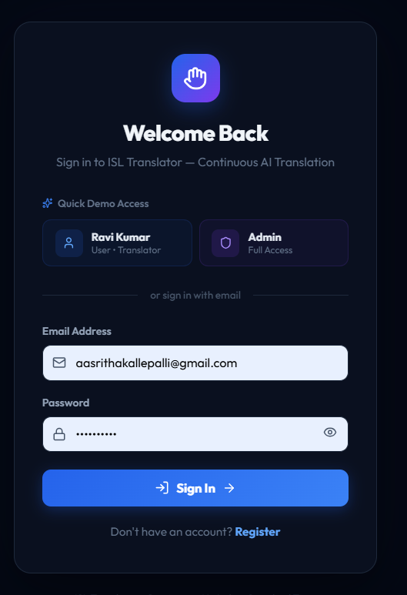
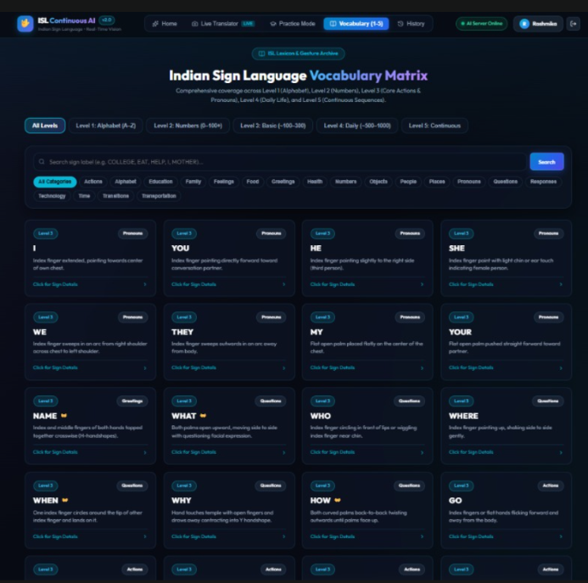

CHAPTER 8: TESTING

Postman API Testing

The FastAPI backend was tested to verify that the application's API endpoints function correctly and communicate properly with the frontend and database. Authentication, user-related operations, gesture-processing requests, translation operations, and history-related requests were tested with valid and invalid inputs. The API responses, status codes, request validation, and error handling were checked to ensure that the backend provides the expected results and handles incorrect requests safely.

Integration Testing

Integration testing was performed to verify the complete interaction between the frontend, FastAPI backend, gesture-recognition components, and MongoDB database. The complete workflow was tested from capturing the camera input and detecting hand landmarks to recognizing the gesture, generating the corresponding text, and displaying the result on the frontend. Database operations such as storing and retrieving user information and translation history were also verified to ensure that all major components work together correctly.

Tools Used for Testing

Postman — Testing FastAPI endpoints and API responses

Browser Testing — Testing the React frontend, user interface, camera access, and translation display

MongoDB Compass — Verifying stored users, signs, translations, and history data

VS Code / Terminal — Running the frontend and backend and checking application errors

Webcam — Testing real-time single-hand and two-hand gesture recognition

Test Cases and Results
A representative sample of the test cases executed, drawn from the project's actual test log, is summarized below.

# | Test Case | Expected Result | Actual Result
1 | Login with valid credentials | User is successfully authenticated | Pass
2 | Login with incorrect credentials | Login is rejected with an appropriate error message | Pass
3 | Access a protected feature without authentication | Access is denied | Pass
4 | Register a new user with valid details | User account is created successfully | Pass
5 | Capture a single-hand gesture | Hand is detected and the supported gesture is recognized | Pass
6 | Capture a two-hand gesture | Both hands are detected and processed correctly | Pass
7 | Perform a supported gesture continuously | Gesture is continuously observed and translated correctly | Pass

# | Test Case | Expected Result | Actual Result
8 | No hand is visible in the camera | System does not generate an incorrect gesture result | Pass
9 | Perform an unsupported gesture | System handles the gesture without producing an invalid translation | Pass
10 | Recognized gesture converted to text | Correct text is displayed on the interface | Pass
11 | Generate speech from recognized text | Corresponding text is converted to speech | Pass
12 | Save a translation to history | Translation is stored successfully in MongoDB | Pass
13 | Retrieve translation history | Previously stored translations are displayed correctly | Pass
14 | Refresh/reopen the application | Stored database information remains available | Pass

The testing process also helped identify issues related to camera access, continuous gesture detection, API communication, and frontend-backend integration. These issues were corrected during development and the affected functionality was retested to verify the fixes. The final testing confirmed that the major components of the Sign Language Translator work together as expected for supported gestures and application operations.

CHAPTER 9: DEPLOYMENT

Steps to Deploy
The application is deployed locally for development and demonstration as follows:
    - Load the schema and seed data: mysql -u root -p < database/schema.sql, then ... < database/seed.sql
    - Start the backend: cd server, npm install, npm run dev (listens on port 5000)
    - Start the frontend: cd client, npm install, npm run dev (listens on port 5173)
    - Open http://localhost:5173 in a browser and log in with a seeded account

Environment Configuration

Application configuration and sensitive information are maintained through environment variables rather than being directly written into the source code. The configuration can include the MongoDB connection details, authentication settings, API configuration, and frontend/backend URLs required for communication between the application components. Sensitive values such as database credentials and authentication secrets should not be committed to version control, while a sample environment configuration file can be provided to document the required variables.

Hosting of Frontend and Backend

For this project, the frontend and backend are hosted locally for development and demonstration purposes. The React frontend runs through the Vite development server, while the Python FastAPI backend runs using Uvicorn. MongoDB runs as the database service and stores the application's user and translation-related information. The frontend communicates with the FastAPI backend through API requests, allowing camera-based gesture recognition, translation, authentication, and database operations to work together during the demonstration.

CHAPTER 10: CHALLENGES & LIMITATIONS

Issues Faced During Development

Difficulty in accurate hand gesture recognition: During development, the system sometimes confused different hand gestures because similar gestures can have similar hand shapes and positions. Variations in hand size, orientation, lighting, and camera angle also affected recognition accuracy.

Difficulty with continuous gesture recognition: Recognizing individual gestures was easier than recognizing a sequence of gestures continuously from a video. The system needed to determine when one gesture ended and another began without incorrectly detecting the same gesture multiple times.

Lighting and background variations: Changes in lighting conditions, complex backgrounds, shadows, and poor camera quality affected the ability of the computer-vision model to correctly detect the user's hands.

Both-hand gesture detection: Some sign language gestures require the use of both hands. Detecting and processing two hands simultaneously introduced additional complexity compared with single-hand gesture recognition.

Real-time processing limitations: Processing video frames continuously requires significant computational resources. Maintaining both recognition accuracy and real-time performance was challenging on systems with limited processing power.

Backend and database integration: Connecting the sign recognition system with the backend and MongoDB database required additional configuration. Managing user information, recognized gestures, and application data while maintaining proper communication between the frontend and backend was another development challenge.

Model confusion between gestures: During testing, certain gestures were incorrectly classified as another gesture. This showed the need for a larger and more diverse training dataset and better model training.

Solutions Applied

To improve *gesture recognition accuracy*, the system was tested using different hand positions, distances, and camera angles. The recognition pipeline was adjusted to improve hand detection before passing the input to the classification model.

For *continuous gesture recognition*, video frames are processed continuously and the recognized gestures are collected as a sequence rather than treating each frame as an independent final prediction. This helps the system build a meaningful sequence of signs that can later be converted into a sentence.

For *lighting and background issues*, the system uses camera-based hand detection and preprocessing techniques to identify the hand region before classification. Testing was performed under different environmental conditions to identify recognition problems.

For *two-hand gestures*, the hand-detection stage was designed to identify multiple hands when they are visible in the camera frame. The detected hand landmarks/features can then be provided to the recognition model for classification.

To address *real-time performance*, unnecessary processing was reduced and the recognition pipeline was designed to process video frames efficiently instead of performing expensive operations on every possible frame.

For *frontend-backend communication*, REST APIs were used to allow the frontend and backend components to communicate. MongoDB was integrated as the database for storing application-related information.

To reduce *incorrect gesture predictions*, additional testing was performed with different examples of the same gesture. The system can be further improved by training the model with a larger and more diverse dataset containing different users, backgrounds, lighting conditions, and hand orientations.

Current Limitations or Known Bugs

- Limited vocabulary: The current prototype recognizes only a predefined set of sign language gestures. It cannot yet recognize the complete vocabulary of a sign language.
- Sentence formation is limited: The system can recognize individual gestures or a limited sequence of gestures, but generating natural and grammatically correct sentences from continuous sign language remains a challenge.
- Recognition accuracy depends on the environment: Poor lighting, camera quality, occlusion, complex backgrounds, and incorrect hand positioning can reduce recognition accuracy.
- Continuous conversation is not fully supported: The current prototype is primarily focused on recognizing predefined gestures. Fully understanding natural, continuous sign language conversations requires more advanced temporal models and a much larger dataset.
- Facial expressions and body movements are not fully considered: Sign language communication can involve facial expressions, body posture, head movement, and other non-manual features. The current system mainly focuses on hand gestures.
- Limited support for different sign languages: Sign languages differ between countries and regions. The current system is trained for a specific set of gestures and cannot automatically support every sign language.
- Dependence on camera quality: The system requires a functional camera with sufficient resolution to detect the user's hands correctly.
- Database and authentication features are limited: The current prototype provides basic backend and database functionality. Advanced features such as comprehensive user authentication, email verification, password recovery, and detailed user activity history can be added in future versions.
- Cloud deployment is not yet implemented: The system has primarily been tested in a local development environment and has not yet been fully deployed to a public cloud environment.

CHAPTER 11: FUTURE ENHANCEMENTS

Planned Features

Support for continuous sign language sentence recognition.

Increase the number of recognizable gestures and vocabulary.

Add text-to-speech to convert recognized signs into voice.

Add speech-to-text for two-way communication.

Improve support for two-hand gestures and facial expressions.

Provide support for multiple sign languages.

Possible Integrations or Optimizations

- Use advanced LSTM/GRU or Transformer models for continuous gesture recognition.
- Improve accuracy using a larger and more diverse dataset.
- Optimize the system for real-time and low-resource devices.
- Deploy the application to the cloud for remote access.
- Add mobile application support for Android and iOS.
- Improve the UI to provide a smoother and more accessible user experience

CHAPTER 12: CONCLUSION

Summary of the Project

The Sign Language Translator was developed to help bridge the communication gap between sign language users and people who do not understand sign language. The system uses computer vision and machine learning to detect hand gestures through a camera and convert them into meaningful text.

What Was Achieved

The system can detect and recognize a predefined set of sign language gestures in real time. A user-friendly frontend, backend APIs, and database were integrated to support the application. The system was tested with different gestures and conditions to evaluate its recognition performance.

Skills Learned

This project provided practical experience in machine learning, computer vision, hand gesture recognition, frontend and backend development, REST APIs, MongoDB, and real-time video processing. It also improved understanding of model testing, debugging, database integration, and developing an end-to-end AI-based application.

CHAPTER 13: REFERENCES

- Python — Official Documentation, https://docs.python.org/3/
- OpenCV — Official Documentation, https://docs.opencv.org/
- MediaPipe — Official Documentation, https://ai.google.dev/edge/mediapipe
- TensorFlow — Official Documentation, https://www.tensorflow.org/
- MongoDB — Official Documentation, https://www.mongodb.com/docs/
- React — Official Documentation, https://react.dev/
- Node.js — Official Documentation, https://nodejs.org/
- Express.js — Official Documentation, https://expressjs.com/
- MDN Web Docs — JavaScript and Web APIs, https://developer.mozilla.org/
- Postman Learning Center, https://learning.postman.com/

CHAPTER 14: APPENDICES

Appendix A: Sample Code Snippet

Real-time hand landmark extraction used by the recognition pipeline:
import cv2
import mediapipe as mp

cap = cv2.VideoCapture(0)
hands = mp.solutions.hands.Hands(
static_image_mode=False,
max_num_hands=1,
min_detection_confidence=0.5
)

while True:
success, frame = cap.read()
if not success:
break

rgb_frame = cv2.cvtColor(frame, cv2.COLOR_BGR2RGB)
results = hands.process(rgb_frame)

if results.multi_hand_landmarks:
for hand in results.multi_hand_landmarks:
# Extract 21 hand landmarks
landmarks = [
(lm.x, lm.y, lm.z)
for lm in hand.landmark
]

cv2.imshow("Sign Language Translator", frame)

if cv2.waitKey(1) & 0xFF == ord('q'):
break

cap.release()
cv2.destroyAllWindows()

Appendix B: Installation and Setup Instructions
- Install Python 3.x and verify:
python --version
- Create and activate a virtual environment:
python -m venv venv
venv\Scripts\activate
- Install the required Python packages:
pip install fastapi uvicorn pymongo bcrypt opencv-python mediapipe tensorflow
- Start the FastAPI backend:
uvicorn main:app --reload
- Open the frontend in a web browser and allow camera permission when prompted.
- Configure the MongoDB connection string in the backend configuration before running the application.

Appendix C: Default Login Credentials
Administrator and user accounts are created according to the application's authentication configuration.
Role | Email
Admin | admin@college.edu
Student | lahari809@gmail.com
Student | devajirashmika@gmail.com

Appendix D: API Reference Summary
22 endpoints across six resources; full request/response examples are in the accompanying Postman collection.

Resource | Endpoints
Auth | POST /auth/register, POST /auth/login
Users | GET /users, GET /users/{id}, PUT /users/{id}, DELETE /users/{id}
Signs | GET /signs, POST /signs, PUT /signs/{id}, DELETE /signs/{id}
Translation | POST /translate, GET /translations/{id}
History | GET /history, GET /history/{user_id}
Admin | GET /admin/users, GET /admin/analytics

Appendix E: Screenshots
The following pages are left for the student to complete with actual screenshots taken from the running application before submission. Suggested screenshots, in order:
- Login Page

- Dashboard
- Vocabulary Matrix (student’s view)

